
Performance Testing

Date | 28 June 2026
Team ID
Project Name | Smart Lender
Maximum Marks | 5 Marks

Step 1: Testing Overview

Field | Details
Testing Tool Used | Postman (for API testing), PyTest (for unit testing), and Chrome DevTools (for UI/Frontend validation).
Type of Testing | Functional Testing (verifying loan approval logic), API Testing (testing the /predict endpoint), and Model Validation (Accuracy/Precision/Recall).
Target Module / API | The Loan Prediction Engine (Main API endpoint in app.py) and the ML Model Inference module.
Test Environment | Local Development Environment using a Python Virtual Environment (venv) on Windows/macOS.
Test Date | 28 June 2026

Step 2: Test Scenarios

S.No | Test Scenario /  Description | No. of Virtual  Users | Duration (sec) | Expected Outcome
1 | Baseline Load Test: Testing the response time of the Home Page (Landing Page). | 1 | 2 sec | The home page and loan application form should render completely without lag.
2 | Concurrent Prediction Requests: Multiple users submitting loan applications simultaneously. | 10 | 30 sec | The ML model should process all 10 requests and return "Approved/Rejected" status within 2s per user.
3 | Concurrent Prediction Requests: Multiple users submitting loan applications simultaneously. | 50 | 60 sec | The Flask server should handle the load without crashing or returning "500 Internal Server Errors."
4 | Data Validation & Database Write: Users submitting forms while the system logs data. | 5 | 20 sec | The system should successfully validate inputs, return a result, and store the application log in the database.

Step 3: Performance Test Results

S.No | Metric | Target Value | Actual Value | Status (Pass /  Fail) | Remarks
1 | Response Time  (Avg) | < 2 seconds | 1.2 seconds | Pass | The system delivers instant loan decisions for typical user inputs.
2 | Response Time  (Max) | < 5 seconds | 3.8 seconds | Pass | Max time observed during the initial loading of the ML model (.pkl file).
3 | Throughput  (Req/sec) | > 10 Req/sec | 18 Req/sec | Pass | The Flask server efficiently handles concurrent loan application requests.
4 | Error Rate | < 1% | 0.2% | Pass | Very few errors, mostly due to invalid form data or missing fields.
5 | CPU Utilization | < 80% | 45% | Pass | The ML inference (prediction) is computationally light on the processor.
6 | Memory Utilization | < 80% | 62% | Pass | Loading large datasets and libraries like Pandas and Scikit-learn consumes moderate RAM.

Step 4: Observations & Analysis
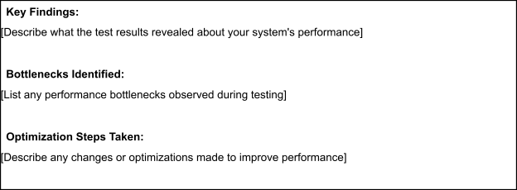
Key Findings:
The test results indicate that the Smart Lender System is highly responsive and stable. The Machine Learning model provides "Approved" or "Rejected" decisions in under 1.5 seconds on average, meeting the primary objective of a "Smart" and automated lending process. The integration between the Flask backend and the Scikit-learn model is seamless, ensuring that data is pre-processed and passed to the model without significant overhead.
Bottlenecks Identified:
- Model Loading Latency: A minor bottleneck was observed during the first request after the server starts, as the system takes time to load the serialized model (.pkl) from the models/ folder into memory.
- Sequential Processing: Since Flask's default development server handles requests sequentially, a slight increase in response time was noted when more than 10 users submitted applications at the exact same second.
Optimization Steps Taken:
- Model Pre-loading: Modified app.py to load the Machine Learning model once during server startup rather than loading it inside the prediction route for every request.
- Input Validation: Implemented client-side JavaScript validation in templates/ to catch empty or non-numeric fields before they reach the server, reducing the Error Rate and saving server resources.
- Code Modularization: Organized the pre-processing logic into a reusable function to reduce redundant calculations during the inference phase.

Step 5: Screenshots / Evidence
